FRAMEWORK
Standard Operating Procedure – Aerated Pile Composting
[your facility] Organics Processing Facility

Date of last revision: ______________

Acknowledgement

Gratitude is expressed to the Secretariat of the Pacific Regional Environment Programme (SPREP) implemented and European Union funded, Pacific Waste Management (PacWaste Plus) programme for the continued guidance to the 15 participating countries to improve organic management in the region.


Learn more about the PacWaste Plus programme:

wwwpacwasteplus.org
Introduction
Organic material received, such as yard organics, fish by-product, and cardboard are the “inputs” or “ingredients” of the [your facility] Compost Facility. It is the role of the Facility Operator to provide the correct conditions for this material to be processed into consistent and quality nutrient-rich compost – while minimising environmental harm, and minimising risks to employee health and safety. This Standard Operating Procedure (SOP) guides the effective composting process, providing supervisors and staff the background and guidance on activities to operate and run the facility safely, effectively, and efficiently.
There are 10 key “stages” recommended for effective composting:

- Delivery
- Decontaminate and Separate
- Shred / Size Reduce
- Mix and Form Static Pile
- Composting
- Maturation
- Screening
- Storage
- Bagging
- Dispatch
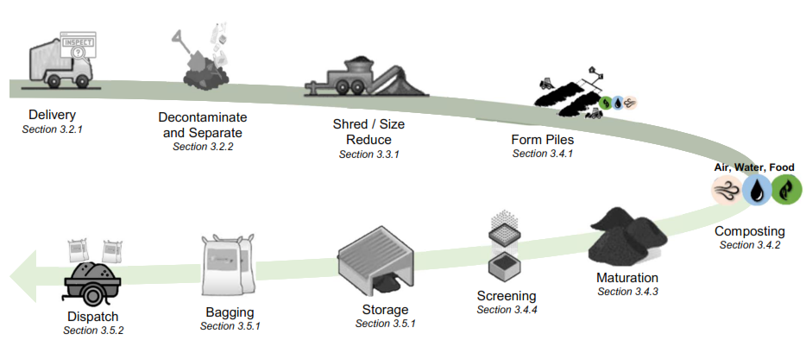
This SOP provides information on recommended tasks to safely and effectively undertake each stage of composting. The SOP is split into three sections:
Part 1 – Quick Guide | Summary information on:  - Overview of the [your facility] Composting Facility operation  - Introduction to the stages of composting and recommended activities for the [your facility] Composting Facility  - Snapshot of daily and weekly tasks for the [your facility] Composting Facility  - Completing daily “Air, Water, Food” Checks on compost piles
Part 2 – Stages of Composting | Detailed information on each of the 10 stages of composting, providing guidance on:  - Recommended tasks to be undertaken at each stage  - Particular health, safety, and environment risks at each stage
Part 3 – Appendix / Further Reading | Further information and background reading:  - Introduction to Composting  - Glossary  - Environmental risks and mitigations  - Health & Safety risks and mitigations  - Safe shredder operations  - Facility maintenance  - Logbook template (data collection)

Part 1 – Quick Guide

Quick Guide: Site Overview
Detail | Description
Current as at | Date: ________________________  (When information changes, update the SOP)
Site Operator | (business or organisation name)
Contact | (person)
Composting Process | Aerated Static Pile Composting
Staff | List staff working at the facility:
Material Throughput | Expected material throughout - volume and type
  Material | Cubic Meter/yard / Week
  Yard Organics
  Food Organics
  Fish Organics
  Paper / Cardboard
  Manure from herbivore animals (pigs, chickens and cows)
  TOTAL
Equipment | List equipment used to operate at the facility:
Equipment | Example:  - Shredder  - Small plant for handling materials  - Aeration units comprising fan, air distribution manifold, and aeration pipes.  - 90cm analogue temperature probe  - 10 Litre Buckets (2x)  - Shovels (wide blade) (4x) | - Gloves (cut resistant)  - Face Masks (P2)  - Data Record sheets  - Screen  - Machete  - Drag fork / pitchfork  - Covers for piles
Training | Staff trained  Composting Fundamentals (list staff trained in composting):  Shredder operation and maintenance (list staff trained in shredder operation and maintenance):
Summary Description - Site and Process | The [your facility] Organics Processing Facility composts organic material using Aerated Static Pile Composting method where organic material is shredded, mixed in a separate Mixing Area, and placed in ## (provide number of piles – recommended minimum of two) square or rectangular piles with forced aeration. Air is forced through the piles using a fan via a series of aeration pipes (sketch your pipes as specified by the equipment provider or using Figure 1 as an example).  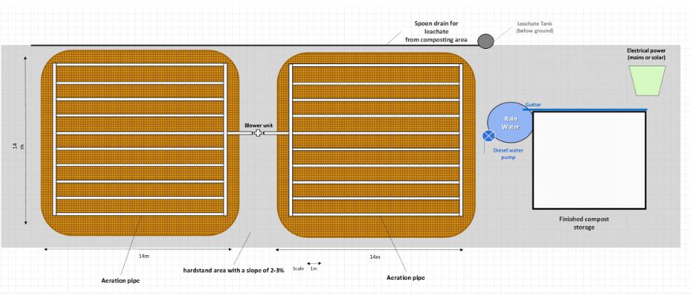  The first pile (Aerated Pile 1) is to place mixed organic material as it is received. After 2-4 weeks, material is turned onto Aerated Pile 2 for active composting (approximately 6 weeks). Once the composting process is complete, the material can be transferred to Maturation Piles to mature for a further 2-4 weeks until it is ready to be screened and sold/provided to community for use.  Laying Pipe and Fans  Aeration pipes for Aerated Pile 1 and 2 are laid on an impervious hardstand area (with suitable drainage) and connected to the pipes and fan. Pipes are placed 1-3m apart on a flat ground surface.  Fans aerate the piles at a rate of 5-7 m3/h per m3 (or 2-3 feet3/h per yard3) of pile volume. Flow rates are adjusted every 10 days with decreasing flow rates over time.  Wood chip or mulch are placed on top of aeration pipes prior to adding the mixed organic material (to help the air flow more evenly through the pile and minimise blockages).  Input Materials  Common input material is …………… (supply details – for example: Yard Organics (### cubic meter/yards / week). This material already contains a mix of Carbon (old, rigid, and dry) and Nitrogen (fresh, flexible, and moist) materials).  Other input material includes …………… (supply details – for example: coconut fronds and paper / cardboard (carbon) and food scraps, copra, and fish-by product (nitrogen)).  Medium sized materials (larger that >1 inch thick and/or >4 inch in length) are shredded.  Materials are mixed in a separate Mixing Area to achieve the right balance of air, water, and food (see Section 1.5) - ensuring there is a mixture of large and small particle sizes, and even amount of carbon and nitrogen materials.  Add Mixed Materials to Aerated Pile 1  The mixed material is placed daily onto Aerated Pile 1 (placed on blowers and layer of wood chip or mulch) from the ‘back wall’ (see details below) forward as materials are received. Water is added to ensure material is damp to touch but not too wet.  At the end of each day, once daily material is added, the pile is covered with a layer of wood chip or mulch to reduce odour.  Material is added to Aerated Pile 1 for 2-4 weeks until pile reaches ###m high and ###m wide (insert pile dimensions from equipment supplier if provided – pile size should determined by ability for material to be aerated with the equipment available - typically 1.5-3.5m high and 5-15m wide)  1.5-4m and width 5-25m  Turning Aerated Pile 1 to the Aerated Pile 2 (Composting)  Two to four weeks following Aerated Pile 1 establishment, material is turned into Aerated Pile 2 for active composting.  Before turning the pile disconnect the pipes and fans and move them away from the pile using a tractor, loader, or excavator.  The pile is turned using a tractor, loader, or excavator and formed on the blowers and layer of wood chip or mulch into Aerated Pile 2.  After turning, Aerated Pile 2 is covered with a 100mm layer of wood chip or mulch and left to compost for 3-6 weeks. No further pile turning should be necessary, unless recommended as a result of daily Air, Food, and Water checks.  Flow rates are adjusted every 10 days with decreasing flow over time  Daily Checks  Daily “Air, Food, and Water” Checks (see Section 1.5) are completed on the Aerated Piles, with a particular note that the aeration system tends to dry out the pile from the bottom up.  During the active composting period (Aerated Pile 2), temperatures should remain over 130°F (55 °C) to ensure “pasteurisation” (seeds and pathogens are killed). If temperatures fall below 130°F (55 °C), the pile should be turned and water added. Consistently low temperatures may require the composting recipe to be adjusted – i.e., additional nitrogen.  Maturation  After approximately 6 weeks, transfer the pile to the Maturation area where it will undergo maturation for a further 2-4 weeks (to ensure the batch receives at least 12 weeks processing) before being screened and bagged for dispatch.

Quick Guide: Stages of Composting and Key Activities
The following table summarise the recommended activities to be undertaken at each stage of composting at the [your facility] Organics Facility. For further details, see the corresponding section of the SOP.
Stage of Composting | Description | SOP Section
Receive:  Delivery, Inspect, Decontaminate, and Separate  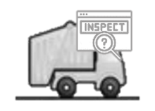  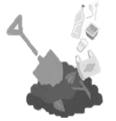 | - Before unloading the delivery truck, visually inspect for contaminants (i.e., plastics, metal, glass, indicators of pesticides (odour or visual), human sludge / biosolids, and rocks & soil)  - if >10% contaminated, REJECT LOAD: notify owner and direct material to landfill  - if material isn’t rejected, unload  - Once material is unloaded, use a shovel to separate / spread to further inspect for and remove contaminants:  - plastics, metal, glass – Put in bin for transport to [landfill / dumpsite name] for recycling / disposal  - pesticides, herbicides – If chemicals are suspected, the load is to be rejected. If chemicals inadvertently received, place material in bin or wrap in tarpaulin and transfer to [landfill / dumpsite name] for disposal  - weeds – confirm they are not covered in pesticide or herbicide. If they are, do not accept – Put in bin or wrap in tarpaulin and transfer to [landfill / dumpsite name] for disposal  - large rocks – separate from organic material and stockpile/use onsite  - Separate organic material by size:  - Small materials (<1 inch thick and <4 inch in length – Transfer to mixing area.  - Medium materials (>1 inch thick and/or >4 inch in length) – Transfer to shredding area  - Large / un-shreddable materials (>9 inch thick) – Use for firewood or stockpile / use onsite  - Wet material (fish by-product etc) – transfer to mixing area (or place on a tarpaulin or a bed of shredded garden organics and cover with shredded garden organics)  - Excess material (that cannot be processed on the day of delivery) can be stockpiled if necessary. Cover with damp cardboard if available. All materials should be formed into the Aerated Pile 1 within 24 hours of delivery to assist with odour management).  - If weeds are handled, use care to ensure seeds are not spread around the facility  - Record data on quantities and types of organics materials received in the logbook (Appendix F) | Section 3.2.1  Section 3.2.2
Processing:  Shred / Size Reduce  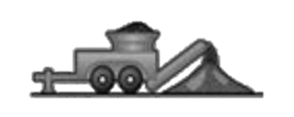 | - Set up shredder and conduct pre-start and safety checks  - Shred medium-sized material following safe operations (Appendix E), feeding the material through stem end first  - Transfer shredded material to mixing area  - If shredded material cannot be formed into a compost batch on same day, stockpile inside and cover with damp cardboard (not essential but can be used if available)  - After use, clean shredder with a brush, closely inspecting for weeds and stuck material  - Inspect for damage and complete shutdown activities. Store shredder indoors.  - Record data on shedder operation in the logbook (Appendix F) | Section 3.3.1
Set up Pipes and Fans | - Lay out aeration pipes for Aerated Pile 1 and 2 on impervious hardstands and connect to pipes and fan.  - Fans should aerate the piles at a rate of 5-7 m³/h per m³ (or 2-3 feet³/min per yard³) of pile volume.  - Place wood chip or mulch on top of aeration pipes prior to adding the mixed organic material
Mix:  Mix and Form Compost Batch (Aerated Pile 1)  2-4 Weeks  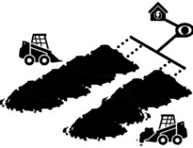 | - Mix new material in a separate Mixing Area to form compost batch – ensuring correct:  - Food - layer even amounts of “Carbon” and “Nitrogen” material. Note: if the common input material is Yard Organics. This material contains both Carbon and Nitrogen so layering is not necessary.  - Air - ensure a mixture of large and small particle sizes to provide airflow into the batch.  - Water - add water so material is damp but not too wet – approximately 55-60%  - Build Aerated Pile 1 on top of the aeration pipes and layer of wood chip or mulch. Use wood chip or mulch to form the ‘back wall’ of the pile (refer to image below)    back wall (side view)    back wall (top view)  - Progressively add mixed materials to Aerated Pile 1 on the aeration pipes from the ‘back wall’ forward.  - At the end of each day, once daily material is added, covered the pile with a 100mm layer of wood chip or mulch  - After 2-4 weeks, when the Aerated Pile 1 reaches full height, disconnect and remove pipes and turn pile to Aerated Pile 2 for composting  - Record data on composition of the batch and results from “Air, Water, Food” checks on the Batch Tags and logbook (Appendix F) | Section 3.4.1
Composting        6 weeks  Air, Water, Food | - After turning to the Aerated Pile 2, cover the pile with wood chip or mulch  - Complete daily “Air, Water, Food” checks to monitor the performance (see Section 1.5)  - Water the pile using a hose or irrigation system to maintain at least 50% moisture content – small quantities daily is best.  - When watering, ensure material is not overwatered or water is allowed to overflow the drain to reduce soil / water contamination  - Track the temperature of the batch to ensure materials heats up to over 130°F (55 °C) and holds this temperature for at least 3 days (heat will kill the weeds and pathogens)  - Check flow rate of aeration pipes, decrease flow of Aerated Pile 2 every 10 days  - After 3-6 weeks, disconnect and remove pipes and transfer material from Aerated Pile 2 to the Maturation area  - Record data on composition of the Pile and results from “Air, Water, Food” checks on the Batch Tags and logbook (Appendix F) | Section 3.4.2
Maturation  2-4 weeks 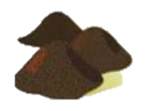 | - Turn pile from Aerated Pile 2 to the Maturation area, which should be separate and upslope from the receival, mixing, and aerated composting areas.  - Record batch name and date on Batch Tag and move the tag with the batch  - Protect the Maturation pile against rain by covering with cardboard (if available) or a tarpaulin, especially if heavy rain is forecast  - Complete “Air, Water, Food” checks daily (see Section 1.5)  - When material looks dark and earthy and the temperature remains cool and stable (i.e., air temperature (under 40oC / 100oF)) the compost is mature and ready for screening and use – check “practical maturity” by measuring CO₂ rate using a CO₂ meter (or Solvita kit if going into bags).  - Track and record maturation process and results from “Air, Water, Food” checks in the logbook (Appendix F) | Section 3.4.3
Screening   | - Screen mature compost through half inch (1-2 cm) sieve  - Fine material that flows though the sieve is finished compost, ready for storage and sale  - Larger particles captured by the sieve can be used as mulch or returned to the active composting process as bio-cover (added Aerated Pile 1) | Section 3.4.4
Storage  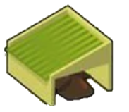 | - Place finished compost in Storage Piles inside the facility or under a cover  - Record batch name and date on Batch tag and move the Batch Tag with the batch  - If compost is to be stored long-term, turn the Storage Pile every two months  - Inspect storage piles weekly, checking for smoke and conduct Air, Water, Food checks  - Temperature should remain cool and stable. If the compost starts getting hot, it indicates it has not finished maturing. Follow actions detailed in the Maturing phase (Section 3.4.3) | Section 3.5.1
Dispatch:  Bag and Dispatch  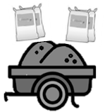 | - If required by customers, place compost into bags for easy handling and transport  - Sell by the bag or trailer load  - Record the batch name and weight / quantity of compost sold/dispatched in the logbook | Section 3.5.1 Section 3.5.2

Quick Guide: Daily Tasks
The following table summarises the recommended daily tasks to be undertaken at the [your facility] Compost Facility.
Image | Actions | SOP Section
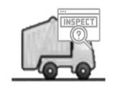 | - Set up receival and mixing area, ensuring delivery vehicles can safely access | Section 3.2.1
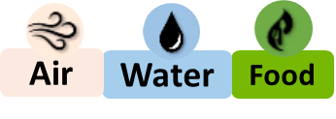 | - Complete daily “Air, Water, Food” checks on Aerated and Maturation piles – complete identified actions  - Check correct flow rate of aeration pipes | Section 1.5
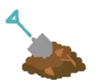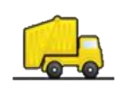 | - Inspect new organic material, decontaminate and separate/sort by size | Section 3.2.1 Section 3.2.2
 | - Set-up shredder and check safety controls  - Safely shred material and compete logbook | Section 3.3.1
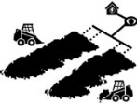 | - Lay pipes and connect manifold and fan  - Mix organic material, ensuring correct balance of Air, Water, Food, and form (on pipes and layer of wood chip/mulch) on Aerated Pile 1 | Section 3.4.1
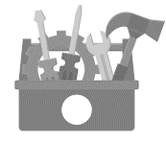 | - Clean and check tools and machinery | Appendix E
 | - Cover Aerated Pile 1 at the end of day with wood chip or mulch | Section 3.4.2 Section 3.4.3
 | - Sweep and clean the site, paying particular attention to weeds or seeds | Section 3.2.2  Section 3.4.2
 | - Empty bins when full and arrange to be transferred to [landfill / dumpsite name] | Section 3.2.2
 | - Record data on logbook and on Batch Tags | Section 1.5  Section 3.2.1 Section 3.2.2  Section 3.3.1  Section 3.4.1  Section 3.4.2  Section3.4.3  Section 3.5.2

Quick Guide: Weekly Tasks
The following table summarises the recommended weekly tasks to be undertaken at the [your facility] Compost Facility.
Image | - Actions | SOP Section
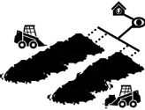 | - Check and update Batch Tags  - Check flow rate of aeration pipes, decrease flow of Aerated Pile 2 every 10 days | Section 3.4.2 Section 3.4.3
 | - Complete “Air, Water, Food” checks on Storage Piles | Section 1.5
 | - Screen and bag (if necessary) finished compost | Section 3.4.4
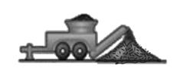 | - Clean tools and machinery, undertake machinery maintenance as needed | Appendix E
 | - Check aeration flow and decrease slightly every 10 days

Daily “Air, Water, Food” Checks
Complete daily “Air, Water, and Food” on Aerated Piles, Maturation Piles, and Storage Piles to monitor the performance of your compost and identify any issues. Keep particular note of presence of smoke, charred compost, or very hot temperatures.
If any issues are identified with the balance of “Air, Water, and Food”, complete the recommended actions as specified.
When completing the smell check, first smell the whole area carefully as you approach the piles. If foul odour is detected, do not handle or closely smell materials. If there is no foul odour in the wider area, continue with smell check – i.e., collect a handful of material and smell carefully. (waft first then if smell faint, get closer to it).
Wear mask, gloves, work boots, and dust resistant eye protection when completing the daily “Air, Water, and Food” checks.
 | Air | Water | Food
 |  |  | 
 | To assess Air: | To assess Water: | To assess Food
Look:    Check the look of the material… | …if material looks (and feels) dry and crispy, it may indicate the pile has too much air  …if material looks stuck/clumped together or there is not a mix of large and small items, it may indicate not enough air  …if material looks loose and moist and has a mix of large and small items, the airflow is about right | …if material looks dry and rigid it may indicate not enough moisture  …if material looks soggy or have a blueish / greenish tint, it may indicate too much moisture  …if material looks loose and moist, moisture content is about right | …if material looks wet and soggy it may indicate too much nitrogen (due to an excess of nitrates)  …if material looks dry and rigid it may indicate not enough nitrogen  …if material looks loose and moist (and feel damp and smells “good”), the food balance is about right
Feel:    Collect a handful of material from about 10cm (4 inches) below the surface and squeeze… |  | …if material feels dry and crispy and no water drops are released, it may mean the pile is too dry  …if the material feels wet and soaking, it may mean the pile is too wet  …if a just few drops of water are released the moisture content is about right
Temperature:  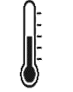  measure with a thermometer, or place a clean machete or shovel into the pile for one minute |  |  | …if pile is <40oC / 100oF) or cool to touch, may indicate too much carbon  … if pile is >65oC / 150oF or too hot to touch, may indicate too much nitrogen  … if pile is ~130°F / 55°C or warm to touch, the food balance is about right
Smell:    smell the area carefully as you approach Pile. If no foul odour experienced, collect a handful of material and smell carefully.  Do not smell close to pile/compost without a mask on. | …if material smells like nothing (and feels dry), it may indicate the pile contains too many large items providing too much airflow  …if material smells “bad” (like rotten egg), it may indicate a lack of airflow  …if material smells “good” (like earthy), it likely means the airflow is about right | …if material smells like nothing (and feels dry), it may indicate the pile needs water  …if material smells “bad” (like rotten egg), it may indicate too much moisture  …if material smells “good” (like earthy), it likely means the moisture is about right | …if it smells like nothing (and feels dry), it may indicate too much carbon  …if it smells “bad” (like rotten egg), it may indicate too much nitrogen  … if it smells “good” (like earthy), it likely means the food balance is about right
Actions   | To remedy lack of airflow (i.e., if there is a foul odour and/or the compost material is clumped together), turn the pile  For the next batch add additional items that are “Helpful for Aeration” (i.e., shredded woody materials) | To remedy lack of moisture (i.e., compost is too dry, and feels old, rigid, and dry), add water slowly during turning. Water can be added by the Pile from a tank via a hose  To remedy too much moisture (i.e., if there is a foul odour and/or it looks soggy and/or there is a blueish / greenish tint), turn the pile and avoid adding more water. For the next batch, add additional dry items that are “Helpful for Aeration” (i.e., shredded woody materials) | To remedy if too much nitrogen (i.e., there is a foul odour and/or temperatures consistently over 70 degrees), turn the pile and add additional items that are “High Carbon” (i.e., shredded woody materials, cardboard).  To remedy too much carbon (i.e., if the compost is cool and there is a surplus of old, rigid, and dry materials), turn the pile and add additional items that are “High Nitrogen” (i.e., fish by-product or grass clipping)

Table of Contents

Acknowledgement 2
Part 1 – Quick Guide 4
1.1 Quick Guide: Site Overview 4
1.2 Quick Guide: Stages of Composting and Key Activities 8
1.3 Quick Guide: Daily Tasks 12
1.4 Quick Guide: Weekly Tasks 13
1.5 Daily “Air, Water, Food” Checks 14
Table of Contents 17
2 Part 2 – 10 Stages of Composting 19
2.1 Introduction / Purpose of this Standard Operating Procedure 19
2.1.1 How to Use this Standard Operating Procedure 19
3 Composting Stages 22
3.1 Start of Shift 22
3.2 Receiving Materials 23
3.2.1 Delivery 23
3.2.2 Decontaminate and Separate 24
3.3 Processing Phase 28
3.3.1 Shred / Size Reduce 28
3.4 Composting Phase 30
3.4.1 Mix and Form Aerated Static Piles 30
3.4.2 Composting 34
3.4.3 Maturation 38
3.4.4 Screening 41
3.5 Dispatch 43
3.5.1 Storage and Bagging 43
3.5.2 Dispatch 45
APPENDIX 47
Appendix A - Introduction to Composting 47
Food: Carbon and Nitrogen 47
Balancing Air, Water, and Food 49
Phases of Composting 50
Useful Resources 51
Appendix B - Glossary 52
Appendix C - Environmental Risks and Mitigations 56
Appendix D - Health & Safety Risks and Mitigations 60
Appendix E - Safe Shredder Operations and Facility Maintenance 62
Appendix F - Logbook Template (Data Collection) 63

Part 2 – 10 Stages of Composting

Introduction / Purpose of this Standard Operating Procedure
Organic material, such as yard organics, fish by-product, and cardboard are the “inputs” or “ingredients” of the [your facility] Compost Facility. It is the role of the Facility Operator to provide the correct conditions for this material to be processed into consistent and quality nutrient-rich compost – while minimising environmental harm, and minimising risks to employee health and safety.
This Standard Operating Procedure (SOP) guides the effective composting process, providing supervisors and staff the background and guidance on activities to operate and run the facility safely, effectively, and efficiently.

How to Use this Standard Operating Procedure
There are 10 key “stages” recommended for effective composting (illustrated in Figure 1 and Figure 2):

- Delivery
- Decontaminate and Separate
- Shred / Size Reduce
- Lay pipes and connect manifold and fan. Mix and Form Aerated Pile 1.
- Composting (Aerated Pile 2)
- Maturation
- Screening
- Storage
- Bagging
- Dispatch

Stages of compost are completed in a sequence, with a “batch” of organic material progressing though each stage until it is processed into finished compost ready for dispatch (use/sale).
Each stage of composting is featured as a Section in Part 2 of the SOP. Information is provided on recommended tasks to be undertaken to complete each stage at the [your facility] Compost Facility, providing details of recommended tasks and actions to be undertaken, and particular health, safety, and environment risks to be aware of.
Figure 2 Key Stages of Composting at the [your facility] Organics Facility

Figure 2 Site Map – [your facility] Facility
Entrance/Exit
Road
Sketch your facility:

Example:
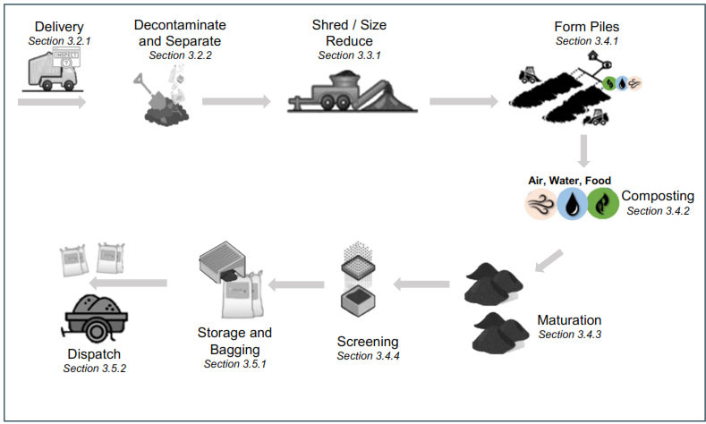

The following organic material types are the common input types and volumes expected at the [your facility] Compost Facility.

Table 1 Common Organic Material Types and Volumes
Organic Material Description | Expected Quantity  m/y³ / Week | Source of Material | Name of Supplier
Yard Organics |  | For example:  Landscapers  Local Government  Household collection
Food Organics
Fish Organics
Paper and Cardboard
Manure from herbivore animals (pigs, chickens and cows)

Composting Stages

Start of Shift
Recommended actions at the start of the shift include:
Action | Details | Photos
Health & Safety Check | Check all employees fit for work and have the correct PPE – mask, gloves, work boots, and dust resistant eye protection – and tools
Set Up Receival Area | Set up receival area, ensuring delivery vehicles can safely access
Set Up Equipment | Set-up shredder and other equipment  Conduct pre-start check - including checking fuel, oil, etc, and inspecting safety equipment (guards in place, blades clear, safety bar, and break, etc)
Daily “Air, Water, and Food” Inspections | Complete daily Air, Water, and Food checks (see Section 1.5) on all Aeration Piles, and Maturation Piles – complete identified actions  Record results on the Batch Tag and logbook (Appendix F)  Keep particular note of presence of smoke or very hot temperatures  When completing smell the check, first smell the whole area carefully as you approach the piles.  Wear mask, gloves, work boots, and dust resistant eye protection
Check Aeration Pipes | Check flow rate of aeration pipes, decrease flow of Aerated Pile 2 every 10 days
Transfer Material (as required) | Check tags to identify material that needs to be transferred to Aerated Pile 2, or to the Maturation Pile.  Before turning Aerated Pile 1 or 2 disconnect the pipes and fans and them away from the pile using a tractor, loader or excavator.  Use caution when working around moving plant (front-end loader, bobcat, telehandler, tractor etc.)

Receiving Materials

Delivery
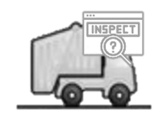
Organic material is delivered to the receival area at the front of the [your facility] Compost Facility. Before unloading, it is visually inspected for contaminants.
Specific actions during the Delivery of Material include:

Action | Details | Photos
Designate Receival Area | Define an area at the front of the site for delivery vehicles to safely access. Allow a safe space for workers to access to inspect the materials. Restrict worker/pedestrian access to remainder of receival area.  Display the Materials Delivery sign  Provide a rubbish bin at the receival area to collect plastics and other contaminants (bin emptied and taken to [landfill / dumpsite name] by next vehicle on return)
Receive Delivery Vehicles | Delivery vehicles access the receival area and await inspection of the load  Keep clear when vehicles are moving
Visually Inspect | Before unloading material, visually inspect to ensure the material is suitable  Look for plastics, metal, glass, chemicals, human sludge / biosolids, and rocks & soil  Use gloves and P2 mask when inspecting or handling the material
Reject if Contaminated | If load is >10% contaminated and/or it is not practical to remove the contamination (e.g., human sludge or pesticides mixed through), REJECT LOAD  Provide feedback to the driver / owner on why load is rejected  Divert driver to take material to the [landfill / dumpsite name] for disposal  Use care if weeds are detected to ensure seeds are contained and not spread on the site
Accept if Clean | If material is clean, accept the delivery and tip the load onto the sorting area
Record Data (Logbook) | Record in the logbook:  - Estimated volume (m³/y³) of organic material accepted  - Delivery driver and where material received from (i.e., households, landscape company, growers)

Specific Health, Safety, and Environment Risks during the Delivery of Material include the following. Mitigation measures are detailed in the Actions Table above (in orange and green text). Further information is contained in Appendix C and D.
Injury From Heavy Vehicle Operation  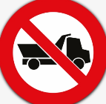 | Exposure to Pathogens   | Exposure to Foreign Objects   | Spread of Weeds   | Windblown Litter  

Decontaminate and Separate
“Contamination” in a compost system can be three different factors:
- Items that will not degrade in the compost system – e.g., plastics, metal, glass
- Items that will inhibit the compost processing or damage the shredder blades – e.g., rocks, soil, large branches (more than 4 inches in diameter), tree stumps, trunks, and excessively stringy vegetation (that will wrap around the shredder feed system and/or knives).
- Items that make the compost unsafe to humans – e.g., chemicals, human sludge

As much contamination as possible are recommended to be removed in the early stages of the compost process, before they get shredded and damage the shredder, or become small pieces spread through the material.
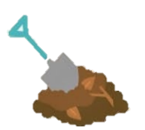
Once received at the [your facility] Facility, organic materials are further inspected, decontaminated, and separated by size to be ready for processing.

Weeds, which are often introduced plant species can pose a significant environmental and economic problem. Garden organics are likely to contain weeds, weed seeds or viable plant parts. The spreading of weeds in mulch or compost is not desirable as it can damage the environment and reduce the value of recycled organic products. People do not want to bring new weeds onto their land when they are using mulch or compost. Viable weed seeds and plant parts are not a problem in most large-scale composting facilities as pasteurisation and the elimination of weed seeds is achieved when temperatures reach 130°F (55 °C) or more for prolonged periods (over 72hrs). Turn at least 5 times to make sure all material is exposed to the high temperatures at the centre of the pile.

Effective weed management within the Facility itself is crucial to preventing contamination of compost products and maintaining quality. Proper site hygiene, including regular removal of weeds around the facility will prevent the risk of spreading unwanted plant species to agricultural or landscaping sites.

Specific actions during the Decontamination and Separation of Materials include:
Actions | Details | Photos
Spread at designated sorting area | Spread material onto a sorting area for inspection. Use a shovel or loader to separate / spread as needed.  Spread any wet material (fish by-product, manure, or food) on a bed of shredded garden organics. Note: if this material appears to be contaminant free, do not spread take straight to mixing area.  Wear P2 mask, gloves, work boots, and dust resistant eye protection when inspecting or handling the material
Inspect and Remove Contaminants | Wear PPE: P2 mask, gloves, work boots, dust resistant eye protection  Check for contaminants (plastics, rocks, soil, etc) in the material. If contaminants are found:  - Plastic, Metal, Glass - Put in bin for transport to [landfill / dumpsite name] for disposal or recycling  - Chemical (e.g. pesticide/herbicide) contaminated yard waste and human sludge - Put in bin for transport to [landfill / dumpsite name] for disposal  - Larger rocks - stockpile for use on site (reused for paths, road, gardens)  - Oversized / Un-shreddable woody material - stockpile for firewood or stockpile / use onsite  Wash hands after handling materials, even when wearing gloves.  If dangerous items found (i.e., broken glass, needles, faeces, toxic chemicals), stop work immediately and notify supervisor and team. Safely collect items and divert to landfill using appropriate PPE and careful handling technique.
Separate Materials by Size | Separate organic materials by size and transfer to appropriate area:  - Small materials such as grass, leaves, and small twigs (<10mm thick and <100mm long) – transfer to mixing area  - Medium materials (>10mm thick and/or >100mm long) – transfer to the shredding area  - Large materials (branches etc too big for shredding equipment) – stockpile for use for firewood or other purpose (e.g. landscaping)  - Wet material (fish by-product etc) – mix and form into Aerated Pile 1 (or place on a bed of shredded garden organics cover with shredded garden organics).  - Wet material to never be placed on bare ground due to potential for soil / water contamination.  - An impermeable floor is required for Aerated Pile 1 and 2 .  If handling large items, use correct lifting and shovelling technique (bend knees not back, keep stance wide and back straight, bend at the hips). Use assistance (people or tools) if handling large items / loads  If weeds are handled, use care to ensure seeds are not spread around the site
Stockpile if Necessary | Stockpile excess material if necessary (i.e., that cannot be processed on the day of delivery)  Cover with damp cardboard (not necessary but can be used if available)  Small and wet material should be mixed and placed in the Aerated Pile 1 or placed on a bed of shredded garden organics and covered with shredded garden organics with within 24 hours of delivery to assist with odour management
Clean-Up | Clear and clean the receiving areas between each load to allow for the next load to be delivered, and to avoid odour and unsightliness, and contaminated water runoff  Clean equipment after use, paying particular attention to any weeds or seeds  Bin collecting plastic, weeds etc to be emptied when full and taken to [landfill / dumpsite name] by next vehicle
Record Data (Logbook) | Record in the logbook:  - quantity and type of organic material received for processing (e.g., 5 m/y3 yard, 0.5 m/y3 fish)

Specific Health, Safety, and Environment Risks during the Decontamination and Separation of Materials include the following.
Mitigation measures are detailed in the Actions Table above (in orange and green text). Further information is contained in Appendix C and D.
Exposure to Pathogens | Exposure to Foreign Objects in Material | Injury from Physical Work   | Sun/Heat Exposure   | Injury from Heavy Vehicle Operation
Spread of Weeds | Windblown Litter | Soil / Water Pollution   | Odour (Air) Pollution   | Spread of Disease  

Processing Phase

Shred / Size Reduce
Once medium-sized material (>10mm thick and/or >100mm) are clean from contaminants it is ready for size reduction / shredding.
Materials can be shredded daily or stored until there is enough material to justify setting up and running the shredder.
Specific Actions During Shredding / Size Reducing of Material:
Actions | Details | Photos
Set-Up Equipment / Conduct Pre-start Check | Set up shredder where processed material can be piled near the mixing area and Aerated Pile 1 (to reduce manual handling)  Conduct pre-start check - including checking fuel, oil, etc, and inspecting safety equipment (guards in place, blades clear, safety bar, and break, etc)
Size Reduce – using shredder | Shred material by trained operators following safe operations (Appendix E)  Feed the material through stem end first  Understand the limitations of the shredder and do not attempt to shred items that will damage the shredder or be unsafe  Wear P2 mask, gloves, work boots, dust resistant eye protection  Remove and dispose any contaminants (plastics, metal, stones, etc)
Size Reduce – shredder not available | If the shredder is not available (out for maintenance etc), options to size reduce material include:  - cut or saw into pieces >4-inch length and diameter (less than the size of a loaf of bread)  - stockpile for firewood - sold or given away)  Use correct cutting technique. Wear mask, gloves, work boots, and dust resistant eye protection
Transfer | Once material is shredded, move to the mixing area.  When moving material, use mechanical assistance (e.g. a small loader) if possible.
Stockpile Material (if necessary) | If material cannot be mixed and placed into the Aerated Pile 1 on the day of shredding, or if there is an excess of a “high carbon” material (e.g., dried palm frond), the material may be stockpiled:  - Store in a space onsite (ideally inside in a covered / dry area) out of the way from daily processing  - Cover the materials with damp cardboard (not necessary but can be used if available) to help materials retain their microbes)  - Record date  Small and wet material should be mixed and formed into Aerated Pile 1 within 24 hours of delivery or placed on a bed of shredded garden organics and covered with shredded garden organics with within 24 hours of delivery to assist with odour management to assist with odour management
Clean, Inspect, and Store Equipment | After use, clean out any residue materials with a brush, taking care to inspect for any weeds or weed seeds  Inspect shredder for damage or bits of material and complete shutdown activities  Store shredder in a covered space
Complete Logbook | Fill in logbook for shredder use (Appendix F), tracking hours of operation and recording management notes/issues/maintenance actions

Specific Health, Safety, and Environment Risks during the Shredding and Size Reduction of materials include the following. Mitigation measures are detailed in the Actions Table above (in orange and green text). Further information is contained in Appendix C and D.
Injury from Shredder Operation  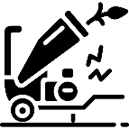 | Exposure to Foreign Objects |  | Injury from Physical Work |  | Sun/Heat Exposure
Spread of Weeds |  | Windblown Litter |  | Odour (Air) Pollution

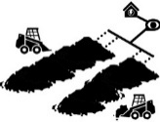


Composting Phase

Mix and Form Batch (Aerated Pile 1)
Organic material is mixed in a separate Mixing Area to achieve the right balance of air, water, and food, and then formed into Aerated pile 1.
Specific actions when mixing material and forming Aerated Pile 1 include:
Actions | Details | Photos
Set up Pipe and Fans | Set up aeration pipes 1-3m apart on the impervious surface as specified by the equipment provider, and connect to the air distribution manifold and fan.  Place a layer (about a foot thick) of “carbon” material such as wood chip or mulch on top of the aeration pipes.
Mix Material | Mix organic material in a separate Mixing Area to achieve the right balance of air, water, and food:
- Adding “Food” with a 30:1 carbon to nitrogen ratio OR with a 50/50 mix of high carbon and high nitrogen materials. | Food – provide the correct C:N ratio:  Review and understand the “carbon” (i.e., materials that are old, rigid, and dry) and “nitrogen”( i.e., materials that are fresh, flexible, and moist) content of input materials  When processing only Yard Organics  - Place shredded and mixed Yard Organic material into Aerated pile , adding new material daily as received  - Continue to add material to the static pile until pile height reaches typically 1.5-3.5m and width 5-15m (depending on equipment and aeration system used)  When processing other Carbon or Nitrogen ingredients  - Mix an even quantity of carbon material with the same quantity of nitrogen material (i.e., add even layers of “nitrogen” material and “carbon” material)  - Mix with loader bucket or shovel (for small quantities).
  If the common input material at your facility is Yard Organics this material is likely to contain a suitable mix of Carbon and Nitrogen materials.
If Adding Cardboard (carbon material):
- Shred dry cardboard into small pieces (less than a half an inch).
- Add cardboard as a “carbon” material at no more than 10% of the overall batch
- Balance cardboard with “nitrogen” materials (such as fish organics)
- Be aware wet cardboard can clump (restricting air and water). Keep close inspection and separate clumps if they form.
Small and wet material should be added to the Aerated pile within 24 hours of delivery or placed on a bed of shredded garden organics and covered with shredded garden organics with within 24 hours of delivery to assist with odour management to assist with odour management
- Ensuring “Air”, providing airflow for the microbes to breath | Air – provide appropriate airflow using the aeration fan, manifold and pipes. Fan usually operate 10-20% of the time balancing air (oxygen) supply with the drying effect. For example, 2 minutes on and 10 minutes off.  Ensure the batch contains a mix of large and small particles (large pieces enabling air to flow).  Ensure material is not clumped together. If clumps form, gently separate.
- Adding “Water”, providing moisture for the microbes | Water – provide the correct amount of moisture:  Depending on the moisture in the feedstock, add water to the pile as new material is added using sprinklers, hose, watering can, or buckets  Add the water slowly - it may take time for it to soak in. Material in the pile should be damp but not too wet.  When adding water, ensure material is not overwatered or water does not run outside the hardstand area to reduce soil / water contamination  Leave the pile overnight then undertake a daily squeeze test (see Section 1.5). Complete identified action.
Formed Aerated Pile 1 | Add mixed organic material to form Aerated Pile 1 on the aeration pipes and bed of wood chip or mulch.  Add material daily as it is received and mixed, forming into pile until it has reached the desired height and width ( approximately 1.5-3.5m in height and 5-15m in width).  Form pile against a wall or bay, or form a ‘back wall’ using wood chip or mulch:  back wall (side view)  back wall (top view)  Add mixed material to Aerated Pile 1 from the ‘back wall’ forward.  At the end of each day, once daily material is added, cover the pile with 100mm of wood chip or mulch.  When the Aerated Pile 1 is fully constructed (# m / # ft high), it is ready to be turned to Aerated Pile 2 for active composting.
Turn to Aerated Pile 2 | Before turning material to Aerated Pile 2, disconnect the pipes and fans and move them away from the pile using a tractor, loader or excavator .  Turn the pile using a tractor, loader, or excavator  Form material on the blowers and layer of wood chip or mulch on Aerated Pile 2.
Daily Checks | Conduct daily Air, Water, Food checks (see Section 1.5) on the pile as it is being formed  Complete identified actions  When completing smell the check, first smell the whole area carefully as you approach the pile. If a foul odour is detected, do not handle or closely smell materials. If there is no foul odour in the wider area, continue with smell test – i.e., collect a handful of material and smell carefully. Do not closely smell any composting materials without a mask on.  Wear mask (except when conducting a smell check), gloves, work boots, and dust resistant eye protection
Record Data (Batch Tag and Logbook) | Record data on the Batch Tags and logbook (Appendix F) to monitor and track the material through the process:  - Pile (Batch) name / number  - Date Batch started  - Input quantity (number of bucket loads) and type  - Daily temperature (help confirm compost process has started)  - Results from daily checks  - Issues identified / actions taken with Batch  - Date of next check  - Any turns and date of each turn  - Planned transfer date to Maturation piles

Specific Health, Safety, and Environment Risks when mixing material and forming a batch include the following. Mitigation measures are detailed in the Actions Table above (in orange and green text). Further information is contained in Appendix C and D.
Exposure to Pathogens | Legionnaires Disease   | Injury from Physical Work | Windblown Litter | Water Pollution | Odour (Air) Pollution

Composting (Aerated Pile 2)
Two to four weeks following Aerated Pile 1 establishment, material is turned into Aerated Pile 2 for the active composting process to commence.
Specific actions during the Composting phase include:
Actions | Details | Photos
Composting | After turning to the Aerated Pile 2, cover the pile with wood chip or mulch  With forced aeration, and with good cover of mulch, it is possible for the compost batch to achieve pasteurisation without turning
Check Aeration and Monitor Compost Process | Check flow rate of aeration pipes, decrease flow of Aerated Pile 2 every 10 days  Measure and record temperatures from various places in the pile (including just under the wood chip/mulch cover). Temperatures of at least 130°F / 55°C must be recorded for at least 3 days to achieve correct pasteurisation.
Daily “Air, Water, and Food” Inspections | Complete daily Air, Water, and Food checks (see Section 1.5)  Record results on the Batch Tag and logbook (Appendix F)  Keep particular note of presence of smoke or very hot (>80ºC) temperatures.  When completing smell the check, first smell the whole area carefully as you approach the Pile. If a foul odour is detected, do not handle or closely smell materials. If there is no foul odour in the wider area, continue with smell test – i.e., collect a handful of material and smell carefully. Do not closely smell any composting materials without a mask on.  Wear mask (except when conducting a smell check), gloves, work boots, and dust resistant eye protection
Undertake Identified Actions | Complete identified actions from the daily Air, Water, and Food checks (see Section 1.5), i.e.,  - If batch identified as too wet, not enough airflow, or contains too much nitrogen material, (i.e., if there is a foul odour and/or it looks soggy and/or there is a blueish / greenish tint), increase aeration and avoid adding more water. Adjust the compost recipe for the next batch by adding additional dry carbon items that are “Helpful for Aeration” (i.e., shredded woody materials)  - If pile identified as too dry or contains too much carbon material, add water slowly and sprinkle over the whole pile. Adjust the compost recipe for the next batch by adding water or additional nitrogen items that are “Helpful for Water Retention” (i.e., fresh damp material such as fish by-product or grass clipping).  When adding water, ensure material is not overwatered or water does not run outside the hardstand area to reduce soil / water contamination.
Composting Complete / Turn to Maturation Pile | Active composting will take at least 6 weeks (depending on the mix).  Track composting process by measuring temperature. Once the pile temperatures consistently drop below 130°F / 55°C, the compost is entering the maturation phase and is ready to be turned to Maturation Pile.  Before turning material to Maturation Pile, disconnect the pipes and fans and move them away from the pile using a tractor, loader or excavator .  Turn the pile using a tractor, loader, or excavator  Form material into the Maturation Pile
Clean-up | Clear and sweep the composting area to avoid odour and vermin, and contaminated water runoff
Record Data (Tag and Logbook) | Keep records of Pile performance by recording data on the Batch Tag and logbook (Attachment 1). Record:  - Pile (Batch) name / number  - Date and number of turns  - Date of Air, Water, and Food checks  - Results from daily checks  - Temperature  - Issues identified / actions taken with Batch  - Date of next Air, Water, and Food check  - Planned transfer date to Maturation piles
Analyse Data | Analyse data to understand and track composting performance and process:  - confirm batch is pasteurised by monitoring temperature - the material gets over 130°F (55°C) and holds temperature for at least 3 days (heat will kill the seeds and cuttings)  - Track phase of composting – when entering the maturation phase, the compost pile will naturally get cooler  - Use data to improve future batches by continually adjusting the compost recipe accordingly  - Consider the cause of any odour incidents and adjust the compost recipe accordingly

Specific Health, Safety, and Environment Risks during the Composting Phase include the following. Mitigation measures are detailed in the Actions Table above (in orange and green text). Further information is contained in Appendix C and D.
Exposure to Pathogens | Legionnaires Disease | Injury from Physical Work | Sun/Heat Exposure
Fire In Composting Material   | Soil / Water Pollution | Spread of Disease | Spread of Weeds

Maturation
Once the composting process is complete, the material can be stored in Maturation Piles to mature for a further 2-4 weeks.
Specific actions during the Maturation Phase include:
Actions | Details | Photos
Build Maturation Pile | The Maturation pile should be built on an impermeable ground surface (e.g. concrete slab) to a sufficient size to contain the entire pile.  Build into triangular pile approximately 5-7ft (1.5 - 2m) high.  When moving material manually use correct lifting and shovelling technique (bend knees not back, keep stance wide and back straight, bend at the hips). Use assistance (people or tools) if handling large items / loads.  Wear mask, gloves, work boots, and dust resistant eye protection  Record batch name and date on Batch tag and place Batch Tag in new material to allow tracking of each batch
Complete Daily “Air, Water, and Food” Inspections and Undertake Identified Actions | Undertake daily Air, Water, and Food (see Section 1.5) checks to track performance and identify issues  Make particular note of presence of smoke or very hot temperatures (>80oC)  Undertake identified actions – i.e., add water if material is too dry, turn if clumping together, etc (Section 1.5)  Track temperature in particular to confirm compost is mature (i.e., material remains cool and stable (i.e. temperature under 40°C / 100°F after turning)  When completing smell the check, first smell the whole area carefully as you approach the Pile. If a foul odour is detected, do not handle or closely smell materials. If there is no foul odour in the wider area, continue with smell test – i.e., collect a handful of material and smell carefully. Do not closely smell any composting materials without a mask on.
Cover | The Maturation pile should be protected from the weather with a roof to avoid run-off and groundwater and surface water contamination. If roofed area not available, a tarpaulin can be used but must be placed to allow air flow through the pile.
Transfer / Turn Maturation Pile | Turn Maturation piles every 2-3 weeks.  Update and move Batch tag with the batch  Use correct lifting and shovelling technique (bend knees not back, keep stance wide and back straight, bend at the hips). Use assistance (people or tools) if handling large items / loads.
Maturation Complete | Compost is mature and ready for screening and use when the material:  - looks dark and earthy  - temperature remains cool and stable (air temperature)  - check “practical maturity” by measuring CO₂ rate using a CO₂ meter (or Solvita kit if going into bags).
Record Data (Batch tag and Logbook) | Record the results of daily checks on the Batch tag and in the Logbook, recording:  - Batch name / number  - Date maturation pile started  - Date of Air, Water, and Food check  - Results from daily checks  - Temperature  - Issues identified / actions taken with pile  - Date of next Air, Water, and Food check  - Planned date for Maturation piles Turn (in approximately 10 days’ time)
Analyse Data | Analyse data to understand performance of particular batches though composting process  Note particular batch’s inputs (yard organics, fish, etc) against speed and performance (issues identified, maturation, temperature etc)  Use data to help inform future compost batch input "recipes” and processing improvements (additional water etc)

Specific Health, Safety and Environment Risks during the during Maturation Phase include the following. Mitigation measures are detailed in the Actions Table above (in orange and green text). Further information is contained in Appendix C and D.
Exposure to Pathogens | Legionnaires Disease | Injury from Physical Work | Sun/Heat Exposure
Fire in Composting Material | Soil / Water Pollution | Spread of Disease | Spread of Weeds

Screening
At the end of the composting process, small pieces of woody material may still be present. The intended use of the compost will determine whether this material needs to be removed though screening. For example, for seed raising, smaller particle sizes are preferred, and the compost is recommended to be screened. For application on a large garden, course materials in the compost are acceptable and screening may not be necessary.
Specific actions during the Screening phase include:
Actions | Details | Photos
Sieve Mature Compost | Place a metal sieve with 1-2cm (1/2 inch) holes over bag or area where you want screened compost to be stored (to avoid double handing)  Ensure compost is slightly damp before screening to reduce dust. Add water with care - if compost is too wet, there may be clumps and the screen may block.  Place a small amount of compost on the sieve at a time  Use correct lifting and shovelling technique (bend knees not back, keep stance wide and back straight, bend at the hips). Use assistance (people or tools) if handling large items / loads.  Shake the sieve from side to side to assist the screening process  Fine material that flows though the sieve is finished compost, ready for bagging and sale  Larger particles captured by the sieve can be used as mulch or returned back to the compost process (added to Pile)  Contaminants such as plastic and stones collected should be removed and placed in a bin for transfer to the [landfill / dumpsite name]
Cleaning | Clean the sieve as you go to remove any build-up of material  Screening will slow down if sieve gets clogged

Specific Health, Safety, and Environment Risks during the during Screening Phase include the following. Mitigation measures are detailed in the Actions Table above (in orange and green text). Further information is contained in Appendix C and D.
Injury from Physical Work | Sun/Heat Exposure | Exposure to Pathogens | Windblown Litter

Dispatch

Storage and Bagging

Mature compost can be stored after screening until dispatched (sold or used). Finished compost can be stored in piles either inside or outside (and covered with a tarpaulin or cardboard boxes). Storage Piles can be taller and wider than the Maturation piles.
Specific actions during the Storage and Bagging phase include:
Actions | Details | Photos
Build Storage Pile | The storage pile should be built on an impermeable ground surface (concrete slab) to a sufficient size to contain the entire pile. Where possible, the pile should be protected from the weather with a roof w to avoid run-off and groundwater and surface water contamination.  Place screened finished compost in Storage Piles. Storage Piles can be taller and wider than the Maturation piles . They must be kept completely separate from unpasteurised materials and up slope from raw material receival and composting activities to avoid any risk of pathogen transfer via leachate.  Record batch name and date on the Batch tag and place Batch Tag on pile of newly sieved material to allow tracking of each batch.
Inspect and Complete “Air, Water, and Food” Checks and Undertake Identified Actions | Inspect storage piles weekly, checking for smoke and conduct Air, Water, Food checks. Keep particular note of presence of smoke or very hot temperatures.  Undertake identified actions – i.e., add water if material is too dry, turn if clumping together  Temperature should remain cool and stable. If the compost starts getting hot, it indicates it has not finished maturing. Follow actions detailed in the Maturing phase (Section 3.4.3).  When completing smell the check, first smell the whole area carefully as you approach the Pile. If a foul odour is detected, do not handle or closely smell materials. If there is no foul odour in the wider area, continue with smell test – i.e., collect a handful of material and smell carefully. Do not closely smell any composting materials without a mask on.
Cover | Cover outdoor Storage Piles with cardboard (if available) to protect and contain material and shelter from rain  If heavy rain is forecast, cover with a tarpaulin if possible.
Turn / Mix Storage Pile | If compost is to be stored long-term, turn the Storage Pile every two months  Update and move Batch tag with the batch  Use correct lifting and shovelling technique (bend knees not back, keep stance wide and back straight, bend at the hips). Use assistance (people or tools) if handling large items / loads.
Bag | If required by customers, place compost into bags for easy handling and transport. Placing in plastic bags helps maintain moisture content and preserve the product while stored.  Use correct lifting and shovelling technique
Record Data (Batch tag and Logbook) | Record data to track how long the material has been stored.  Record data on the Batch tag and in the Logbook, recording:  - Batch name / number  - Date storage pile started  - Date of Air, Water, and Food check  - Results check  - Issues identified / actions taken with pile  - Date of next Air, Water, and Food check  - Date of estimated Storage Pile Turn (approximately 2 monthly)

Specific Health, Safety, and Environment Risks during the during Storage and Bagging include the following. Mitigation measures are detailed in the Actions Table above (in orange and green text). Further information is contained in Appendix C and D.
Exposure to Pathogens | Legionnaires Disease | Injury from Physical Work | Fire in Material

Dispatch


Load bags or compost onto a vehicle to be transported to [provide details where composts will be sold] for sale to the public.

Specific actions during the Dispatch Phase include:
Actions | Details | Photos
Delivery / Dispatch | Load bags of compost onto a vehicle to take to customers, OR sell by the trailer load  Use correct lifting technique (bend knees not back, keep stance wide and back straight, bend at the hips). Use assistance (people or tools) if handling large items / loads  Keep clear when vehicles are moving
Record Data (Logbook) | Record the batch name and volume of compost sold/dispatched in the logbook  Record:  - Volume sold  - What type of customers (i.e., householders, growers, government, landscape companies etc)  Analyse data to understand who is using the material (to help inform future operations and improvements)
Specific Health, Safety, and Environment Risks at the Dispatch Phase include the following. Mitigation measures are detailed in the Actions Table above (in orange and green text). Further information is contained in Appendix C and D.
Injury from Heavy Vehicle Operation | Injury from Physical Work  

APPENDIX

Appendix A - Introduction to Composting
Compost is a nutrient rich product that looks and smells like dark, earthy garden soil. Compost is used to enhance soils, which assists with plant growth, crop yields, and water retention. Composting mimics nature’s method of decomposition, allowing organic material to break down “aerobically”, with oxygen. Creatures too small to see (microbes) process organic materials and convert it to compost. Microbes, like humans and animals, need three elements to live and thrive: Air, Water, and Food. Effective composting occurs when these three elements are operating in a balance.
The function of Air, Water, and Food and how they assist the process of composting are explained in the following figure.
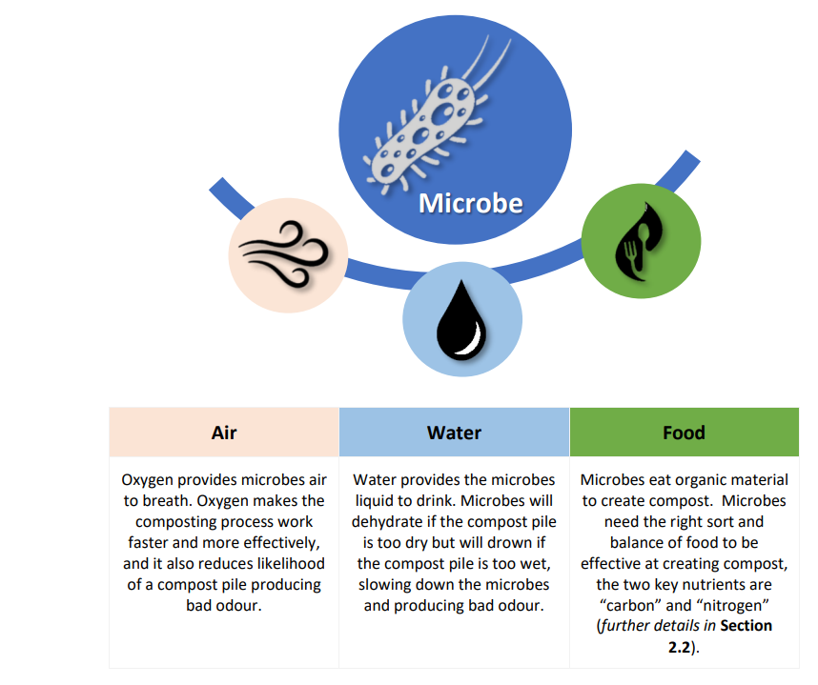

Food: Carbon and Nitrogen
Food is a key part of the balance in a compost pile as this is what the microbes eat, and just like humans they need a balanced diet – with the “carbon” (used as a source of energy) and “nitrogen” (for building cell structure) being the key ingredients. All organic matter includes both carbon and nitrogen; just in different percentages. Microbes need more carbon than nitrogen, coincidentally most materials have a higher carbon percentage. Types of “carbon” and “nitrogen” sources in the Pacific and Timor Leste and their ratios are provided in Figure 3.












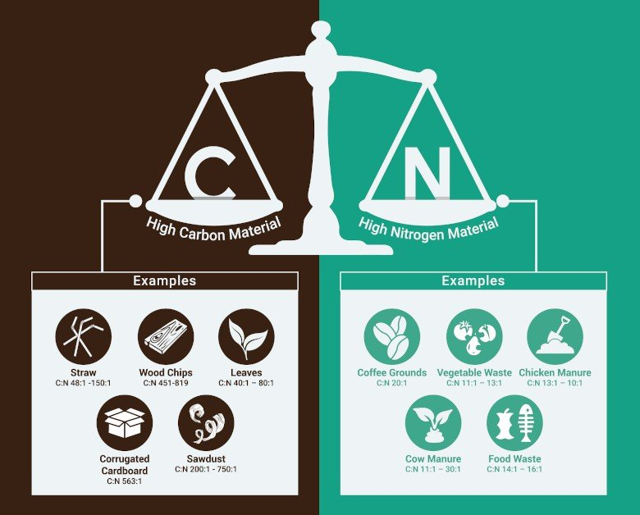
Figure 3 Carbon and Nitrogen Materials Ratios
Palm & Flax
C:N 70:1

Coconut Husks
C:N 100:1
Paper & Card
C:N 500:1

Seaweed
C:N 13.5:1
Sawdust
C:N 300:1
Molasses
C:N 98:1
Fish
C:N 5:1
Food Organics
C:N 9:1

Copra
C:N 11:1
Animal Manure
C:N 12:1
Beer
C:N 12:1
Coffee
C:N 27:1
Carbon Materials =  Old, rigid, and dry | Nitrogen Materials =  Fresh, flexible, and moist

For effective composting, the ideal “Food” or carbon to nitrogen ratio (C:N) of a compost pile is C:N 30:1. The following extract from the PacWastePlus Composting Common Materials Handbook provides guidance on how to calculate this ratio.
Figure 4 Options for Calculating 30:1 C:N
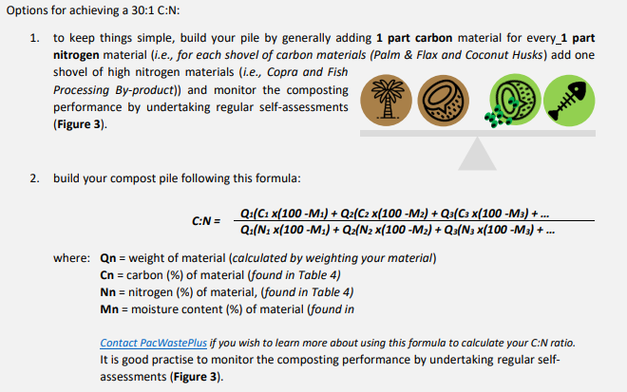


Note:

The common input material at the [your facility] Facility is Yard Organics.

This material already contains a mix of Carbon (old, rigid, and dry) and Nitrogen (fresh, flexible, and moist) materials. Once shredded this can be added to the Pile without further blending with other carbon and nitrogen sources.

Balancing Air, Water, and Food
Compost is more than the sum of its parts; it is a living ecosystem. Understanding the materials in the system – and how they balance together to provide the Air, Water, and Food the microbes need – is the foundation for building a healthy compost pile.
Different organic material types have different carbon and nitrogen contents, different particle sizes, and different water retention capabilities. Understanding the behaviour of each material type and their influence on Air, Water, and Food, compost operators can mix materials and develop their own compost “recipes” to turn the organic materials they have into valuable compost.
For example, palm fronds in a compost pile provide high carbon food, and can enhance airflow of a compost pile, but may inhibit water retention. To make effective compost, this material may be layered with items such as by-product from fish processing, which is a high nitrogen food, and can enhance water retention, but may inhibit airflow.
More detail on the composting of common materials found in the Pacific can be found in the PacWastePlus document: Composting Common Organic Materials: Handbook for Compost Operators.
Assessment of the Air, Water, and Food and ensuring a correct balance in your compost pile can be completed using a self-assessment. See Section 1.5 for details to complete an assessment on Air, Water, Food.

Phases of Composting
The compost process has three stages - determined by different microbes doing their work. The stages are: Initiation Phase, Thermophilic Phase, and Maturation Phase. Understanding and tracking the stages will allow operators to know where in the process the compost is and ensure the “pasteurisation” (sanitating and seed killing) phase has occurred.
Figure 5 Phases of Composting
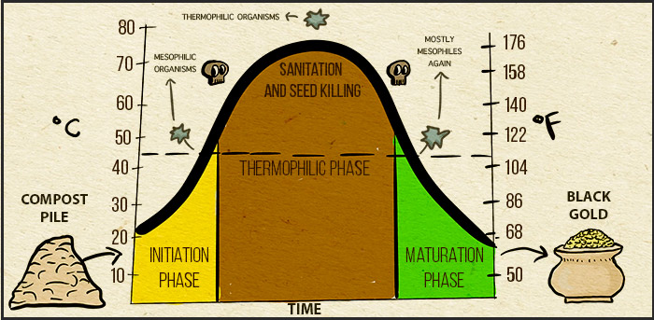
Source: The Science of Compost - Basic to Advanced (untamedscience.com)

Initiation Phase
At the start of a composting process there is a lot of “food” and microbes work fast to rapidly break it down. As they do so they produce heat that causes the temperature to rise.
This process takes a few days and is indicated by rapid rise in temperature.
Thermophilic Phase
While microbes have completed the initial break down of material, there is still enough food for them to continue to work. The pile will be warm but not rising rapidly.
The Thermophilic Phase will start to occur in the Aerated pile during pile formation and throughout the composting phase. Correctly applied, the cover of wood chip or mulch can insulate the fresh material so that pasteurisation temperatures can be achieved for all fresh materials in the pile.
The microbes will be further breaking down the material into finer pieces. The warmth of the pile will provide pasteurisation and enable weeds and pathogens to be killed off. Note: the material needs to be over 130°F (55 °C) for 3 or more days to provide the pasteurisation to occur.
Warning: If the pile gets too hot the microbes will die, stopping the composting process. The compost requires regular monitoring of Air, Water, and Food and undertaking identified actions such as providing aeration (mixing), and/or water to help control the heat.
Once the microbes have broken down the material (eaten all the available “food”), they slow down, and the temperature of the pile decreases. This process can take approximately 12 weeks and can be tracked by measuring the temperature of the compost pile – once the temperature has cooled down the pile has likely reached the end of the Thermophilic Phase.
Maturation Phase
The microbes continue the maturation and curing of the compost to its final stage.
The Maturation Phase will commence approximately 12 weeks after formation commences and should be allowed to continue for at least 4 weeks in the Maturation pile.
Once it no longer heats up, despite maintenance of the correct moisture content and aeration, the compost is finished.

Useful Resources
- Composting Common Organic Materials in the Pacific and Timor-Leste: Handbook for Compost Operators
- Guidelines and Standards for Composting and Compost Quality for Pacific Island Countries and Timor Leste.
- Organics Factsheet: Aerated Static Pile Composting

Appendix B - Glossary
Word | Definition
Aerated Pile | Freestanding piles with forced aeration and little or no turning. Materials may also be contained by bins or bunkers instead of freestanding piles
Aerobic process | Composting process with oxygen or air, as opposed to an anaerobic process (without oxygen)
Air (In relation to checks) | Oxygen provides microbes air to breath. Oxygen makes the composting process work faster and more effectively, and it also reduces likelihood of a compost pile producing bad odour.
Anaerobic process | Composting process in which organic matter is degraded by micro-organisms in the absence of oxygen, as opposed to an aerobic process (with oxygen)
Bacteria | Smallest living organisms and the most numerous in compost; they make up 80-90% of the billions of microorganisms typically found in a gram of compost. Bacteria are responsible for most of the decomposition and heat generation in compost. They are the most nutritionally diverse group of compost organisms, using a broad range of enzymes to chemically break down a variety of organic materials.
Batch | A quantity of organic materials composted together at the same time and under the same conditions.
Bioaerosol | Bacteria or fungi in drops of mist in the air
Bio-cover | Layer of at least 100mm and up to 300mm of wood chip or mulch laid over unpasteurised waste material to insulate, minimise moisture loss, and reduce odour.
Carbon | Energy-element and is one of the basic building blocks of life. Plants are nearly half carbon. In composting, carbon provides an energy food that sustains the microbes. Materials high in carbon are typically old, rigid, and dry – for example fallen palm fronds and flax/tree litter, dry branches and leaves, and paper / cardboard.
Carbon to Nitrogen (C:N) ratio | The proportion or ratio of the amount of carbon to the amount of nitrogen required in a compost pile. This ratio can be calculated for a mix of different materials to be composted. A C:N ratio of 30:1 is recommended for effective composting.
Air, Water, Food Compost Check | Recommended daily checks on the Air, Water, and Food in a compost pile to understand its performance (see Section 1.5)
Compost | Organic material that has been broken down during composting and now looks and smells like dark, fertile garden soil
Composting | A natural biochemical process in which naturally occurring microorganisms transform raw organic materials into compost products. Although these processes are natural and will happen on their own, compost facility operators are recommended to understand and control the process to provide ideal environmental conditions for bacteria, fungi, and other decomposing organisms.
Composting facility | Facility that accepts compostable material, and processes this into compost through either aerobic or anaerobic processes
Compostable material | Material that was once part of a living thing. Includes: clippings from Yard beautification projects, fallen palm fronds and flax/tree litter, peelings and scraps from food preparation, by-product from food production facilities, manure, and paper / cardboard. Does not include petrochemicals. Has the same definition as organic material.
Contamination | The presence of objects and items that will compromise the compost process. Contamination may include plastics, metal, glass, pesticides, and human sludge.
Decontaminate | To remove the contamination of objects and items that will compromise the compost process.
Fungi | A group of spore-producing organisms feeding on organic matter. Fungi include moulds, yeast, and mushrooms. Fungi are heterotrophs (cannot make their own food) and have a key role in nutrient cycling in an ecosystem.
Food (In relation to checks) | Referring to the organic material that the Microbes eat to create compost. Microbes need the right sort and balance of food to be effective at creating compost, the two key nutrients are “carbon” and “nitrogen”
Food organics | Residues from food, which can be from food preparation, such as fruit and vegetable peelings and trimmings, or leftover, unconsumed food. Spoiled food that is no longer fit for consumption.
Foot / feet (ft) | Imperial unit of measurement. 1 yard is equivalent to 0.3048 meters. is equivalent to 0.91 meters. 1 yard comprises three feet.
Garden Organics | Refer to Yard Organics
Leachate | Liquid that seeps out of a compost pile. Typically produced if the compost has been overwatered.
Manifold | A pipe fitting that connects multiple inputs or outputs
Maturation Pile | A pile of material that is in the maturing phase of the process.
Meter (m) | Metric unit of measurement. 1 meter is equivalent to 1.09 yards
Microbes | Tiny living organisms including bacteria and fungi which process organic materials into compost. There are billions of microbes typically found in a gram of compost
Mix Material | The action of physically turning organic materials to mix them together.
Nitrogen | Protein-element essential for growth and reproduction in both plants and animals. In composting, microbes use nitrogen to grow and reproduce. Materials high in nitrogen are typically fresh, flexible, and moist – for example fresh clippings from yard/community clean-up projects, peelings and scraps from food preparation, and manure.
Organics / Organic Material | Materials that were once part of a living thing. Includes: clippings from yard/community beautification projects, fallen palm fronds and flax/tree litter, peelings and scraps from food preparation, by-product from food production facilities, manure, and paper / cardboard. Does not include petrochemicals. Has the same definition as compostable material.
Odour | Bad smells. In compost facilities odour comes from not enough oxygen (Air), or too much nitrogen.
Palm Organics | Trunks and leaves (fronds) from palm trees and similar species. Contains tough fibres that can be hard to shred, and size reduce.
Pasteurisation | Stage in composting where the heat from the composting process kills seeds and pathogens. Pasteurisation occurs at temperatures above 130°F / 55°C. Typically the composting material needs to be turned several times, and the temperature maintained above 130°F / 55°C for at least 3 consecutive days to ensure effective pasteurisation (killing of weeds and pathogens).
Pathogen | Microorganism (bacteria, fungi, virus) that can cause disease or death in plants, animals, or humans. Typically the composting material needs to be turned several times, and the temperature maintained above 130°F / 55°C for at least 3 consecutive days to ensure killing of pathogens).
Screen | Tool that has sides and a mesh on the bottom through which the finished compost (soil) will be shaken through to help remove (screen) large particles.
Shred | The action of cutting the material up into smaller pieces. Assists the composting process. The shredder may be used or other tools like a machete.
Shredder | Mechanical machine designed to break up woody organic material into smaller pieces.
Turning | Mixing and “fluffing up” of composted material. Turning involves moving material on the outside of the pile goes into the inside of the pile and material at the top of the pile gets moved to the bottom of the pile.
Virus | Infectious agent that replicates only within the cells of living hosts, mainly bacteria, plants, and animals. Many viruses cause diseases as part of their reproduction process.
Water (In relation to checks) | Referring to the action of checking how much moisture is in the pile. Water provides the microbes liquid to drink. Microbes will dehydrate if the compost pile is too dry but will drown if the compost pile is too wet, slowing down the microbes and producing bad odour.
Yard | Imperial unit of measurement. 1 yard is equivalent to 0.91 meters
Yard Organics | Vegetation residues from yards, community areas, or landscaping. Can include grass clippings, leaves, weeds, crop residues, twigs, branches, vines, palm fronds. This material contains a mix of carbon and nitrogen materials (and therefore can be added to a compost pile without further blending with other carbon or nitrogen sources).

Appendix C - Environmental Risks and Mitigations
Composting is generally perceived as positive in its impact - reducing waste disposed to landfill, minimising the generation of methane and leachate, and produces a valuable nutrient-rich material which can increase soil quality and crop yield.
However, when not undertaken appropriately, composting may pose a risk to the environment, human health, and the amenity of residents.
Without following an effective composting process, as described in this SOP, the [your facility] Compost Facility could cause or increase environmental risks such as:
- Spread of weeds
- Water pollution
- Odour (air) pollution
- Attraction of vermin
- Spreading of disease
By understanding the potential environmental impacts from composting will assist in understanding the importance of following good composting practices.
Below is a table that identifies the key potential environmental at the [your facility] Organics Facility, and what you can do to avoid those risks.
Table 2 Environmental Risks and Mitigations / Considerations
Risk | Description | Management
Spread of Weeds | Weeds are introduced plant species, difficult to control, and are a leading driver of biodiversity loss in the Pacific.  The main weeds in [YOUR COUNTRY] include: | Weeds can be safely received and composted at the [your facility] Facility by following set “rules” to ensure all the seeds and cuttings are pasteurised (“killed” by the heat from the composting process) during the composting process.  Actions to reduce spread of weeds at the [your facility] Facility include:  - During the composting process, the material in the Aerated pile gets over 130°F and holds this temperature for at least 3 days after each turn (heat will kill the seeds and cuttings)  - care given to ensure seeds are not spread around the site  - care given to ensure equipment is well cleaned after use  - Remove/spray any weeds growing in an near the facility before they go to seed  Note: care is also recommended to ensure weeds to be composted are not covered in weed killer/pesticide such as paraquat as this will affect the quality of the compost. Before accepting weeds at the site, confirm with the owner that the material is not covered in pesticide. If it is, it is best to divert the material to landfill.
  Garden organics received at the [your facility] Facility are likely to contain weeds, weed seeds, or viable weed parts.
  It is the responsibility of the [your facility] Facility to ensure these weeds are managed and composted correctly. Without correct processing and pasteurisation, the compost produced may spread weeds to areas where the compost is placed.
Water Pollution   | Water runoff from compost facilities can be high in nutrient and particulate matter (“leachate”) which, without management, can pollute nearby surface and groundwater. | Actions to reduce leachate and runoff at the [your facility] Facility include:  - layering new wet materials, particularly fish/food organics, on top of dry materials and never on bare ground  - undertake composting activities inside the containment area  - Construct a spoon drain around the Aerated pile to capture leachate from the composting area.  - do not overwater or allow water to run outside the containment area  - place the Maturation piles on an impermeable surface  - protect the Maturation piles against rain by covering with cardboard (if available) or a tarpaulin, especially if heavy rain is forecast.
Odour   | The breakdown of organic materials at a composting facility produces a range of smells, some of which are offensive to neighbours.  Odour is one of the most common causes of community pollution reports and conflict relating to composting operations.  The main potential odour sources (smells) at the [your facility] Facility are raw food organics, including from fish processing. Food organics can be smelly if they:  - have begun to decay  - are stored on-site prior to being formed into a composting batch with the correct carbon nitrogen ratio  - are left uncovered and exposed on the surface of the compost  During the process of turning Piles odour can be generated when composting material is turned | Actions to minimise odour at the [your facility] Facility include:  - create a balanced compost recipe considering Food, Air, Water (correct carbon to nitrogen ratio, mix of small and large particle sizes, and correct amount of moisture)  - complete “Air, Water, Food” checks daily (see Section 1.5)  - do not overwater  - protect Maturation piles against heavy rain
Vermin and Scavenging Animals   | Vermin (e.g., mice, rats, cockroaches) and scavenging animals (e.g., dogs, cats) are attracted to organic materials (particularly food and fish by-product etc). Vermin and scavenging animals are a nuisance because they dig into compost to get to food, often leaving a mess, and can transmit diseases.  Once the food and fish organics are partially broken down by the composting process, vermin and scavengers loose interest. Therefore management is most critical in the initial stages of the process (delivery, separating, shredding, mixing and building Piles).  Cockroaches are not a problem in compost, in fact they assist with the breakdown of organic materials, but their presence might create unease for some people. | Actions to minimise the attraction of vermin and scavenging animals at the [your facility] Facility include:  - mix food and fish organics into the Aerated pile as soon as possible, do not store in the open or leave uncovered  - create a balanced compost recipe with correct carbon to nitrogen ratio (refer to Section 3.3 and 6.3.1).  - consider fencing / barricading the site, or at a minimum the Aerated and Composting piles, to discourage vermin and dog/cat access
Spreading of Disease | Organic materials can contain microorganisms that have the potential to adversely affect the health of people working at the site, the wider environment (biosecurity), and the amenity of neighbours.  Proper pasteurisation (ensuring temperatures reach 130°F for at least 3 days) of the compost material will eliminate most human, animal, and plant pathogens. | Actions to manage pathogens and minimise the spreading of disease at the [your facility] Facility include:  - screen incoming organic materials – refusing material that might have human pathogens such as human sanitation waste / sludge, and taking PPE precaution (listed in Table 2) when accepting and handling material such as animal manure  - ensuring the material in the Pile get over 130°F and holds at this temperature for at least 3 days (heat will kill the pathogens)  - ensure workers understand the risks, use appropriate PPE equipment and wash hands frequently (detailed in Appendix D)

Appendix D - Health & Safety Risks and Mitigations
Health and safety are key considerations in everything we do to ensure that we all go home to our families at the end of every workday, happy, safe, and healthy. It is important we look after ourselves and our team while working at an Organics Facility to ensure we have a safe and enjoyable place to work.
Below is a table that identifies the key potential risks to worker health and safety at the [your facility] Organics Facility, and what you can do to avoid those risks.
Table 3 Health and Safety Risks and Mitigations / Considerations
Risk | Description | Management
Exposure to pathogens and bioaerosols (i.e., viruses, bacteria, parasites) | Adverse reactions to the viruses, bacteria and/or parasites that can be living in compost.  Exposure may occur during handling or screening. It may cause skin irritations, eye infection or respiratory illness. People with a weakened immune system, asthma or a punctured eardrum are at greater risk. | - Prevent people with a weakened immune system, asthma or a punctured eardrum from being involved in composting activities  - Avoid breathing dusts or mists - wear a P2 mask  - Wear gloves, work boots, dust resistant eye protection  - Wash hands after handling new materials and compost  - Wash work clothing regularly  - Screen incoming materials and reject material with risk, such as human sanitation waste (sludge)
Legionnaires disease | Disease of the lungs that is caused by a bacteria that may live in compost. | - Wear a P2 face mask when handling, turning or watering composting material  - Do not get too close when smelling composting materials  - Wear gloves when handling composting material  - Wash hands before eating
Injury from physical work | Injury due to handling heavy materials, or repeated movements such as turning Piles | - Use correct lifting and shovelling technique  - When lifting bend your knees not your back, keep your stance wide and back straight.  - When digging or shovelling, keep your back straight, feet wide and facing the shovel and bend at the hips  - Use assistance (people or tools) for large loads
Foreign objects in material | Foreign objects in the material that could cause a wound or health risk.  Examples: broken glass, needles, faeces, toxic chemicals | - If found/seen stop work immediately and notify supervisor/team. Safely collect items using appropriate PPE and careful handling technique and divert to landfill.  - Use tools (shovels etc) when handling material where possible  - Use gloves and face masks
Health Risk from sun/heat exposure | Hard physical work in the sun and heat can cause dehydration, sunburn, heat exhaustion or heat stroke | - Drink water  - Work in the shade during hottest part of the day  - Take breaks  - Work in teams  - Wear sun protection
Fire in the composting material | Fires can self-ignite in a compost pile, burning workers and damaging the equipment facility. Fires can be smouldering internally in the piles so can pose an unexpected threat.  Fires risk is higher in large, unturned, old piles, as well as piles with high quantities of cooking oil or grease. | - Monitor compost daily though “air, food and water” checks (see Section 1.5)  - Mix any oil and grease received at facility with high carbon material (reject oil and grease if quantities too high too process)  - Complete a Fire Facility Inspection with the local fire department and ensure recommended fire equipment is in place – water supply, smoke alarms, hoses etc  - Train staff on how to use fire equipment and handle fire  - If very hot temperatures or a small amount of smoke in a compost pile is observed:  - Open the pile with a metal tool (spade/loader)  - Spread pile out  - Spray water on it  - Re-Mix pile
Injury from Heavy vehicle operation | Heavy vehicles operating on site, delivering loads.  Injury can occur from being hit by vehicle, pinched by vehicle parts moving (dump tray), or being crushed by load. | - Have designated areas for heavy vehicle operation  - Keep staff clear when vehicles are moving and operating  Install flashing lights and reversing beepers on vehicles  - Make eye-contact with driver if near/assisting  - Communicate vehicle’s intentions onsite
Injury from shredding:  People caught, cut or burned by parts of machine.  People pulled into shredder  Electrical Shock | Potential for injury from shredder blades, operation or object being thrown from shredder.  Injury can also occur from electric shock | - Machine operators receive adequate training  - Operate machinery in pairs  - Have appropriate guards on machinery (hot, moving, sharp parts)  - Have an emergency safety bar and ensure users know how it works  - Remove all rocks and other contamination from material before shredding  - Isolate (turn off/remove keys) machine to clear any blockages or do maintenance  - Avoid putting hands/face near blades or moving parts  - Clearly communicate with other workers when shredder is in use  - Keep power cables dry and check for exposed wire frequently. Use an electrician to fix or modify.

Appendix E - Safe Shredder Operations and Facility Maintenance
Maintenance is necessary to keep infrastructure, tools, and equipment operational, clean and tidy to avoid accidents, pollution of the environment, and for continued successful operation of the facility. Detailed below are the equipment and infrastructure that requires maintenance at the [your facility] facility.
Where possible assign the maintenance activity to a specific person or role.
Equipment | Things to consider
Machinery | Ensure that the following is available:  - engine oil  - grease  - tool to sharpen blades  - key  - spare parts (e.g., new blades)  - tools for working on the equipment (spanners / screw drivers)
Machinery | Staff have been nominated as machine operator and have received training:
Hand tools | Ensure hand tools (shovels, forks, etc) and spare parts if required are available  Keep equipment in good repair
Composting Piles | Ensure correct tools are used and no risk of injury when handling parts of the equipment or when transferring material.  Clean as necessary by sweeping and hosing-down with water
Screen | Keep screen in good repair, clear from build-up of material

Appendix F - Logbook Template (Data Collection)
Template for Data Collection - see separate excel sheet
Data collected on:
Material received:
- Estimate volume (m³/y³) of organic material accepted
- Delivery driver and where material received from (i.e., household collection, landscape company, growers)
- Volume and type of organic material received for processing (e.g., 5 m³/y³ yard, 0.5 m³/y³ fish)
Compost batch composition and commencement:
- Pile name / number
- Date Pile started
- Input quantity (number of bucket loads) and type
- Daily temperature (help confirm compost process has started)
- Results from daily checks
- Issues identified / actions taken with batch
- Date of next check
- Planned first turn date
Compost batch performance:
- Pile name / number
- Date Pile turned
- Date of Air, Water, and Food checks
- Results from daily checks
- Temperature
- Issues identified / actions taken with batch
- Date of next Air, Water, and Food check
- Planned turn date (if any)
Maturation pile performance:
- Pile name / number
- Date maturation pile started
- Date of Air, Water, and Food check
- Results from daily checks
- Temperature
- Issues identified / actions taken with pile
- Date of next Air, Water, and Food check
- Planned date for Maturation Pile Turn (in approximately 10 days’ time)

Storage pile performance:
- Pile name / number
- Date storage pile started
- Date of Air, Water, and Food check
- Results check
- Temperature
- Issues identified / actions taken with pile
- Date of next Air, Water, and Food check
- Date of estimated Storage Pile Turn (approximately 2 monthly)
Compost sold/dispatched:
- Volume sold
- What type of customers (i.e., householders, growers, government, landscape companies etc)
Shredder operation:
- Hours of operation (to ensure maintenance occurs at regular intervals)
- Management issues

The overall space required is typically 450 m2 / 538 yd2 (about 1 basketball court) for facilities processing 1 tonne/day. Open space (equivalent to the length of the pile) is required next to the pile for pulling out aeration pipes. The pile footprint will also depend on the size and type of machinery used – efficiencies of pumps, the quantity of material available to form a sufficient sized pile etc.
Flow rates are adjusted every 10 days with decreasing flow over time
See Section 7 on measuring maturity in Guidelines and Standards for Composting and Compost Quality
Use Section 2.1 of the Composting Materials Handbook
“simple” method to achieve C:N 30:1. To calculate C:N 30:1 using formula see Section 2.1 of the Composting Materials Handbook)
Steel cables or chains are sometimes required for pulling out aeration pipes.
Keeping records of the speed and the behaviour of materials and different ratios of input ingredients will enable further understanding of the most effective compost blends for the specific situation. Record keeping allows learning and improvement as well as better management of the process. Recording keeping should start when forming each Pile and kept throughout the composting process.
Steel cables or chains are sometimes required for pulling out aeration pipes.
See Section 7 on measuring maturity in Guidelines and Standards for Composting and Compost Quality
Information may be found on the SPREP Pacific Invasive Species - Battler Series Portal https://brb.sprep.org/

